Как настроить инспекцию кода в PyCharm

**Pylint**

В настройках проекта нужно поставить пакет и настроить его через External tools

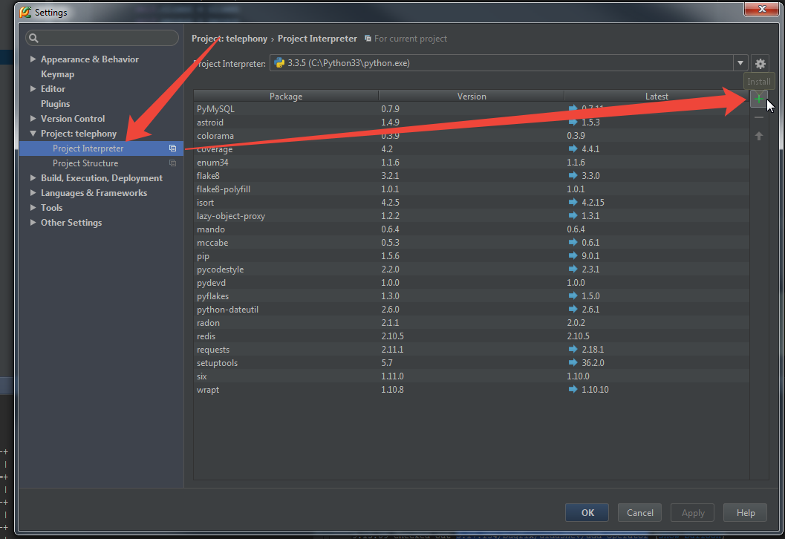

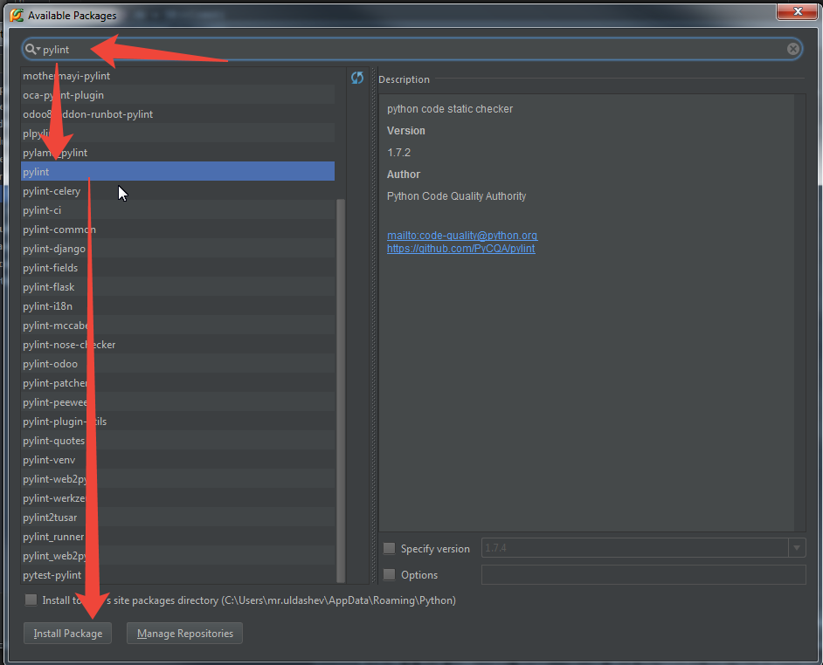

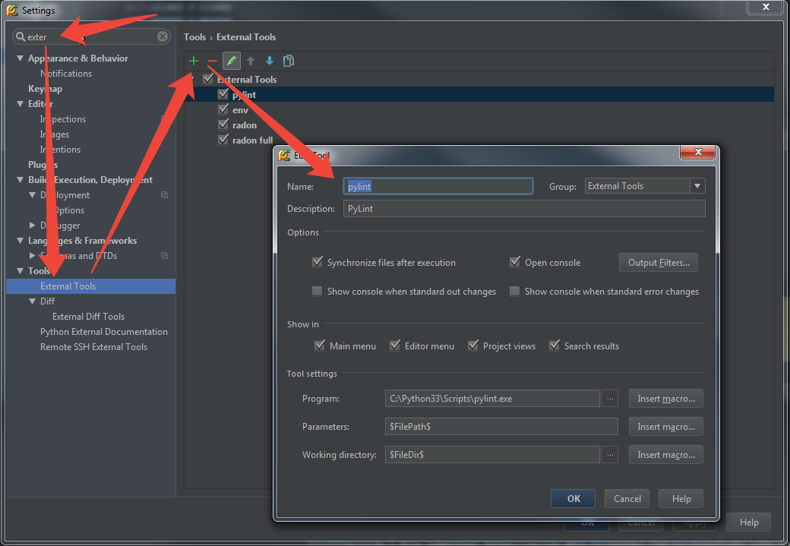

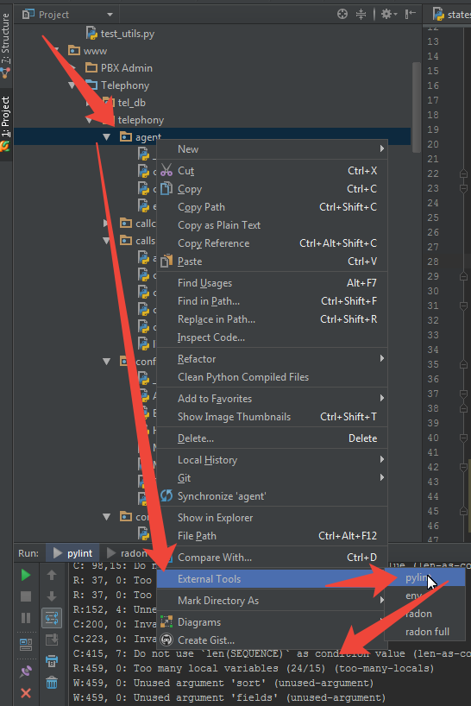

**Файл с настройками pylint**

**Содержимое меню настройки Tools/External Tools/Edit Tool в PyCharm:**

Program: C:\Python33\Scripts\pylint.exe

Parameters: $FileName$ --rcfile="C:\Python33\Scripts\.pylintrc_2"

Working directory: $FileDir$

Содержимое файла .pylintrc_2Ж

[MASTER]

# Specify a configuration file.

#rcfile=

# Python code to execute, usually for sys.path manipulation such as

# pygtk.require().

#init-hook=

# Profiled execution.

profile=no

# Add files or directories to the blacklist. They should be base names, not

# paths.

ignore=CVS .git .hg

# Pickle collected data for later comparisons.

persistent=yes

# List of plugins (as comma separated values of python modules names) to load,

# usually to register additional checkers.

load-plugins=

[MESSAGES CONTROL]

# Enable the message, report, category or checker with the given id(s). You can

# either give multiple identifier separated by comma (,) or put this option

# multiple time.

#enable=

# Disable the message, report, category or checker with the given id(s). You

# can either give multiple identifier separated by comma (,) or put this option

# multiple time (only on the command line, not in the configuration file where

# it should appear only once).

# Brain-dead errors regarding standard language features

# W0142 = *args and **kwargs support

# W0403 = Relative imports

# Pointless whinging

# R0201 = Method could be a function

# W0212 = Accessing protected attribute of client class

# W0613 = Unused argument

# W0232 = Class has no __init__ method

# R0903 = Too few public methods

# C0301 = Line too long

# R0913 = Too many arguments

# C0103 = Invalid name

# R0914 = Too many local variables

# E0602 = Undefined variable

# PyLint's module importation is unreliable

# F0401 = Unable to import module

# W0402 = Uses of a deprecated module

# Already an error when wildcard imports are used

# W0614 = Unused import from wildcard

# Sometimes disabled depending on how bad a module is

# C0111 = Missing docstring

# Disable the message(s) with the given id(s).

disable=W0142,R0201,W0212,W0613,W0232,R0903,W0614,C0111,F0401,W0402,R0914,C0111,E0602

[REPORTS]

# Set the output format. Available formats are text, parseable, colorized, msvs

# (visual studio) and html

output-format=text

# Include message's id in output

include-ids=no

# Tells whether to display a full report or only the messages

reports=yes

# Python expression which should return a note less than 10 (10 is the highest

# note). You have access to the variables errors warning, statement which

# respectively contain the number of errors / warnings messages and the total

# number of statements analyzed. This is used by the global evaluation report

# (RP0004).

evaluation=10.0 - ((float(5 * error + warning + refactor + convention) / statement) * 10)

# Add a comment according to your evaluation note. This is used by the global

# evaluation report (RP0004).

comment=no

[BASIC]

# List of builtins function names that should not be used, separated by a comma

bad-functions=map,filter,apply,input

# Regular expression which should only match correct module names

module-rgx=(([a-z_][a-z0-9_]*)|([A-Z][a-zA-Z0-9]+))$

# Regular expression which should only match correct module level names

const-rgx=(([A-Z_][A-Z0-9_]*)|(__.*__))$

# Regular expression which should only match correct class names

class-rgx=[A-Z_][a-zA-Z0-9]+$

# Regular expression which should only match correct function names

function-rgx=[a-z_][a-z0-9_]{2,30}$

# Regular expression which should only match correct method names

method-rgx=[a-z_][a-z0-9_]{2,30}$

# Regular expression which should only match correct instance attribute names

attr-rgx=[a-z_][a-z0-9_]{2,30}$

# Regular expression which should only match correct argument names

argument-rgx=[a-z_][a-z0-9_]{2,30}$

# Regular expression which should only match correct variable names

# variable-rgx=[a-z_][a-z0-9_]{2,30}$

variable-rgx=[a-z_]?[a-z0-9_]{2,30}$

# Regular expression which should only match correct list comprehension /

# generator expression variable names

inlinevar-rgx=[A-Za-z_][A-Za-z0-9_]*$

# Good variable names which should always be accepted, separated by a comma

good-names=i,j,k,ex,Run,_

# Bad variable names which should always be refused, separated by a comma

bad-names=foo,bar,baz,toto,tutu,tata

# Regular expression which should only match functions or classes name which do

# not require a docstring

no-docstring-rgx=__.*__

[FORMAT]

# Maximum number of characters on a single line.

max-line-length=120

# Maximum number of lines in a module

max-module-lines=1000

# String used as indentation unit. This is usually " " (4 spaces) or "\t" (1

# tab).

indent-string=' '

[MISCELLANEOUS]

# List of note tags to take in consideration, separated by a comma.

notes=FIXME,XXX,TODO

[SIMILARITIES]

# Minimum lines number of a similarity.

min-similarity-lines=4

# Ignore comments when computing similarities.

ignore-comments=yes

# Ignore docstrings when computing similarities.

ignore-docstrings=yes

[TYPECHECK]

# Tells whether missing members accessed in mixin class should be ignored. A

# mixin class is detected if its name ends with "mixin" (case insensitive).

ignore-mixin-members=yes

# List of classes names for which member attributes should not be checked

# (useful for classes with attributes dynamically set).

ignored-classes=SQLObject

# When zope mode is activated, add a predefined set of Zope acquired attributes

# to generated-members.

zope=no

# List of members which are set dynamically and missed by pylint inference

# system, and so shouldn't trigger E0201 when accessed. Python regular

# expressions are accepted.

generated-members=REQUEST,acl_users,aq_parent

[VARIABLES]

# Tells whether we should check for unused import in __init__ files.

init-import=no

# A regular expression matching the beginning of the name of dummy variables

# (i.e. not used).

dummy-variables-rgx=_|dummy

# List of additional names supposed to be defined in builtins. Remember that

# you should avoid to define new builtins when possible.

additional-builtins=

[CLASSES]

# List of method names used to declare (i.e. assign) instance attributes.

defining-attr-methods=__init__,__new__,setUp

[DESIGN]

# Maximum number of arguments for function / method

max-args=5

# Argument names that match this expression will be ignored. Default to name

# with leading underscore

ignored-argument-names=_.*

# Maximum number of locals for function / method body

max-locals=15

# Maximum number of return / yield for function / method body

max-returns=6

# Maximum number of branch for function / method body

max-branchs=12

# Maximum number of statements in function / method body

max-statements=50

# Maximum number of parents for a class (see R0901).

max-parents=7

# Maximum number of attributes for a class (see R0902).

max-attributes=7

# Minimum number of public methods for a class (see R0903).

min-public-methods=2

# Maximum number of public methods for a class (see R0904).

max-public-methods=20

[IMPORTS]

# Deprecated modules which should not be used, separated by a comma

deprecated-modules=regsub,string,TERMIOS,Bastion,rexec

# Create a graph of every (i.e. internal and external) dependencies in the

# given file (report RP0402 must not be disabled)

import-graph=

# Create a graph of external dependencies in the given file (report RP0402 must

# not be disabled)

ext-import-graph=

# Create a graph of internal dependencies in the given file (report RP0402 must

# not be disabled)

int-import-graph=

**Radon**

Пакет добавляется аналогично pylint, но запуск настраиваем иначе:

Открываем Run – Edit configurations и добавляем следующим образом.

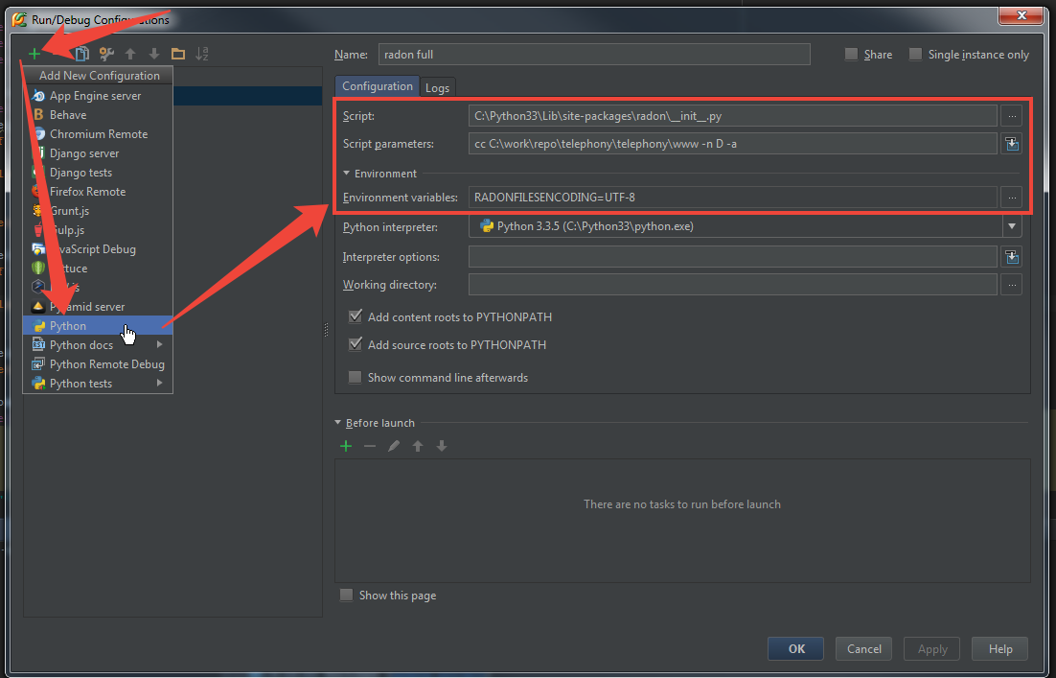

В Script parameters указываем директорию www из проекта.

Environment variables – обязательно указываем RADONFILESENCODING=UTF-8 , иначе проверка свалится на файлах с русскими буквами.

Запуск через Run.